Learning Contract for Olive
2nd grade unit: Narratives
ELACC2RL3: Describe how characters in a story respond to major events and challenges.

ELACC2RL6: Acknowledge differences in the points of view of characters, including by speaking in a different voice for each character when reading dialogue aloud.

ELACC2W3: Write narratives in which they recount a well-elaborated event or short sequence of events, include details to describe actions, thoughts, and feelings, use temporal words to signal event order, and provide a sense of closure.

Expectations of behavior:
- Stay on task at all times.
- Manage your time wisely. Make a plan for what you hope to accomplish each day.
- If you are confused, get stuck, or need help please ask me during independent work time.
- Be respectful to your peers and do not brag about getting to do a different assignment.
- Only work on your project during independent work time, not during your required learning time.
- Be creative and give 100 percent!

Required by the teacher:
- Mini lessons during reading and writing blocks with the whole class
- Homework assignments

Required independent activity:
- Read Charlie and the Chocolate Factory by Roald Dahl
- Daily journaling of what you have read

Student Choice Activities: (chose one)
- Mr. Wonka and the Chocolate Factory
- What happens to Charlie?

What you will learn:
As you read Charlie and the Chocolate Factory you will notice and begin to be able to describe how characters respond differently or in ways we may not expect to major events or challenges. I selected this book because the characters have very different reactions to major events. You will also be able to think about point of view and how the story can change depending on it. Reading out aloud, using different voices for each character, will further enhance your understanding of point of view so I recommend that you do this.
After reading Charlie and the Chocolate Factory, you will get to use this mentor text to create a narrative. In our mini lessons and through your reading you will learn about sequencing, including details to describe thoughts, feelings, and actions, using temporal words, and providing closure. You will then be given the opportunity to use what you have learned and practice creating your own narrative.

Time:
You will have the reading and writing block for two full weeks to complete this contract.
Resources:
You will be provided with the following materials:
- The book Charlie and the Chocolate Factory
- Paper, pencils, pens
- A laptop (for any research you may want to do or for creating your product)

Positive and negative consequences:
- If you complete the activity independently, follow the guidelines, and give your best effort, you will get to share your published work with the fifth grade classes. You can also make your work available for anyone in the library.
- If you do not follow the contract rules, you will lose the privilege to participate in this activity and a phone call to your parents will be made.

*Disclaimer
The book Charlie and the Chocolate Factory contains some curse words. I will talk to your parents and we will all decide together whether you can handle reading them or if I need to mark them out before giving you the book.

I __________________ promise to complete the required activities of this learning contract while giving my best effort. I will choose the activity that best meets my interest and will complete it independently.
Student signature: _________________________ Date:____________
Teacher signature:_________________________ Date:____________

Reading and journaling of Charlie and the Chocolate Factory

I would like for you to write a short journal entry each day about what you have read. I will look at this each afternoon to make sure you comprehend what you are reading.
Please include:
- A brief summary of what happened
- Your feelings about the characters and events taking place
- Any questions you have
- Words that were difficult for you
- Predictions you have
- Anything else you would like to share

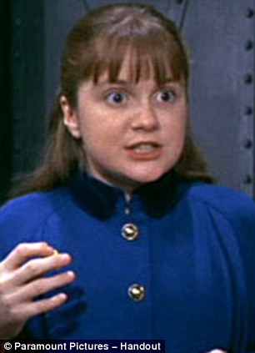
Mr. Wonka and the Chocolate Factory

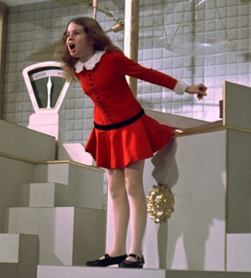
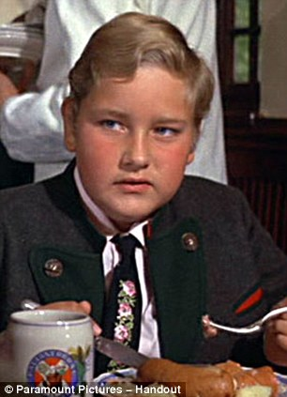

Directions: Choose one of the other main characters in Charlie and the Chocolate Factory:
- Mr. Willy Wonka
- Augustus Gloop
- Veruca Salt
- Violet Beauregard
- Mike Teavee
- An Oompa-loompa
Think about the events in Charlie and the Chocolate Factory from your chosen character’s perspective. Write a narrative about the some of the events occurring in Charlie and the Chocolate Factory from their perspective. I have provided you with a graphic organizer to help you organize your thoughts.

You will be learning about point of view in the mini-lessons, but I have included some other resources for you to use as well.
https://www.brainpop.com/english/writing/pointofview/preview.weml (Brain pop Jr. video about point of view)
http://www.studyzone.org/testprep/ela4/o/pointofviewl.cfm (examples of point of view and a quiz to help you practice identifying it)

I have provided you with a checklist of things you must include. This is the criteria your work will be evaluated on. Please feel free to be as creative as you would like and add more.

Checklist:
- Catchy title
- Background information of the character you choose
- Their feelings about the other characters
- At least three events from Charlie and the Chocolate Factory in our character’s perspective (for example, if you choose August Gloop you must talk about events from his perspective before he is sucked up the tube)
- How the character feels after the events have taken place
- Sequencing of events
- Details describing characters’ actions, thoughts, and feelings
- Use of temporal words
- Correct spelling, capitalization, and punctuation

Character:
Event | The book’s perspective | Your character’s perspective

What happens to Charlie?
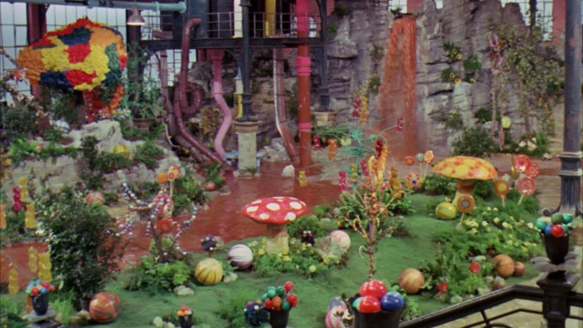
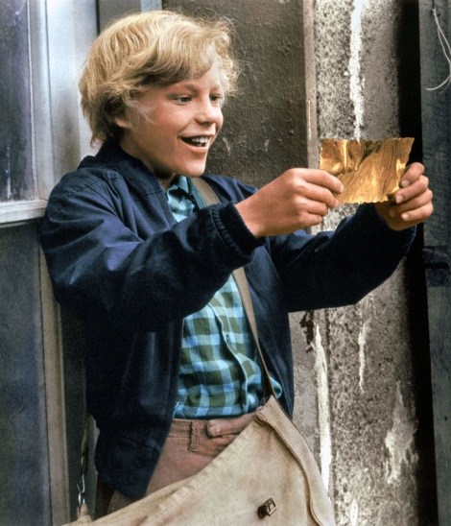

Directions: Choose one of the following styles of writing to create a narrative about what happens to Charlie after he inherits the chocolate factory. I have provided you with a graphic organizer to help you think about the elements you need to include.
- Script
- Diary or journal entries
- Poem

I have provided you with a checklist of things you must include. This is the criteria your work will be evaluated on. Please feel free to be as creative as you would like and add more.

Checklist:
- How does Charlie feel about inheriting the chocolate factory?
- Describe his relationship with Mr. Wonka
- What does he choose to do with the chocolate factory?
- Does he have any contact with Veruca, Violet, Mike and Augustus?
- Sequencing of events
- Details describing characters’ actions, thoughts, and feelings
- Use of temporal works
- Correct spelling, capitalization, and punctuation

Charlie’s feelings about the factory | Relationship with Mr. Wonka
What does he do with the factory? | Does he have contact with Veruca, Violet, Mike, and Augusts?

