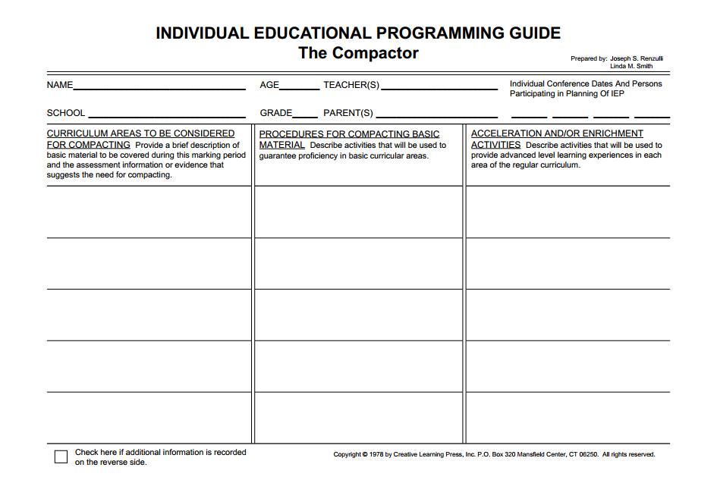

Olive will read *Charlie and the Chocolate Factory* and have a choice of narrative writing opportunities. A learning contract will be developed for this activity.

Olive will visit the narrative learning spot. Narratives from multiple authors will be available to compare and contrast, as well as narratives from different reading levels and different cultures. Supplies will be available for students to try writing their own narratives based on the mentor texts.

Olive will participate in a book club with the other three students reading on a fifth grade level. The club can choose one of the following books: James and the Giant Peach, Matilda, and The BFG. Each student will take turns leading discussions about the narrative features of the book. After reading the book, each student will write an alternative ending to share with their peers.

Olive will be expected to complete any homework assignments given throughout the unit.

Olive truly enjoys reading, writing, and performing. She has written her own novel about a second grade girl who saved the world from pollution with the help of a giant super-hero beetle, “The Litter Bug.”

Olive will be expected to participate in all mini-lessons about the characteristics of narrative reading and writing – sequencing, temporal words, characters’ responses to major events, point of view, and use of details to describe actions, thoughts and feelings.

Abby Crowe

2

Olive

Olive scored in the 99th percentile on achievement and creativity tests given to determine giftedness. Olive is only in the second grade, but reads on a fifth grade level.

ELACC2W3: Write narratives in which they recount a well-elaborated event or short sequence of events, include details to describe actions, thoughts, and feelings, use temporal words to signal event order, and provide a sense of closure.

ELACC2RL6: Acknowledge differences in the points of view of characters, including by speaking in a different voice for each character when reading dialogue aloud.

ELACC2RL3: Describe how characters in a story respond to major events and challenges.