Bibliotherapy: addressing hiding giftedness

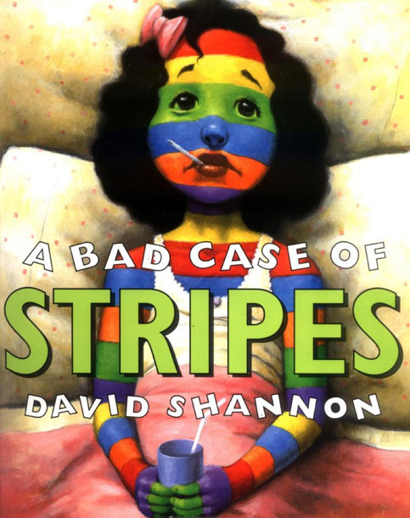
A Bad Case of Stripes is a book about a young girl named Camilla Cream who suddenly develops a striped hue that no doctor can explain. Her skin keeps changing as she develops red and white stripes and blue stars. Eventually she starts growing twigs and berries and becomes a part of her walls. Several different doctors try various strategies with poor results. When an old woman suggests she eat some lima beans, Camilla refuses because “no one likes lima beans.” When Camilla can no longer move, she agrees to eat the lima beans. After Camilla is healed she eats lima beans every day and gives no thought to what her friends think.

Opening: Ask students to write down something they like that other people may not like or something that they are embarrassed to admit. Have students save the slips of paper.
Mini-lesson: Read The Bad Case of Stripes by David Shannon or play it from http://www.storylineonline.net/
Work time: Have an open discussion about Camilla’s situation. Here are some discussion questions you could include:
- Why do you think Camilla did not want to eat lima beans? Have you ever refused to do something because of what others might think?
- Do you think you would have eaten the lima beans like Camilla? Have you ever done something you were not comfortable doing at first?
- How did Camilla eating the lima beans impact the other kids? How can you impact other kids with your decisions?
- Did Camilla handle her embarrassment in a good way? How can you handle yours?

Closing: When students are comfortable and have discussed why being embarrassed is okay, but should not stop us from doing thinks we enjoy, have the students share their slips of paper with each other.

